[H₃O⁺]
-log[H₃O⁺]
10^{-pH}
[pH]

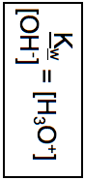
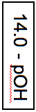
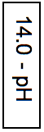
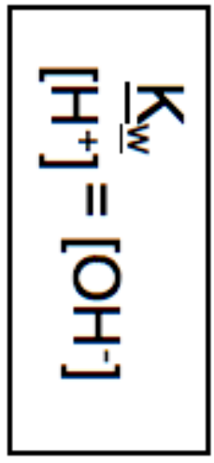

[OH⁻]
[pOH]
10^{-pOH}
-log[OH⁻]

